Amazon Degree Audit

For this data audit, we have selected Amazon’s shopping reference and customer review of analysis.

Description of the data.

The data we are planning to focus on is preference and customer review on amazon. First, Amazon’s preference had save what you view and search, so that they can be able to be recommend related or similar product to you to increase their sales volume. In the picture shown below, if you looked for camera lens and leave the page, this will be shown. When you come back later in the future, you can always see what searched for in the past. It will show many related camera lenses similar to the ones viewed before. Amazon also collect what you had purchased to recommend to people who have searched similar keywords as you.
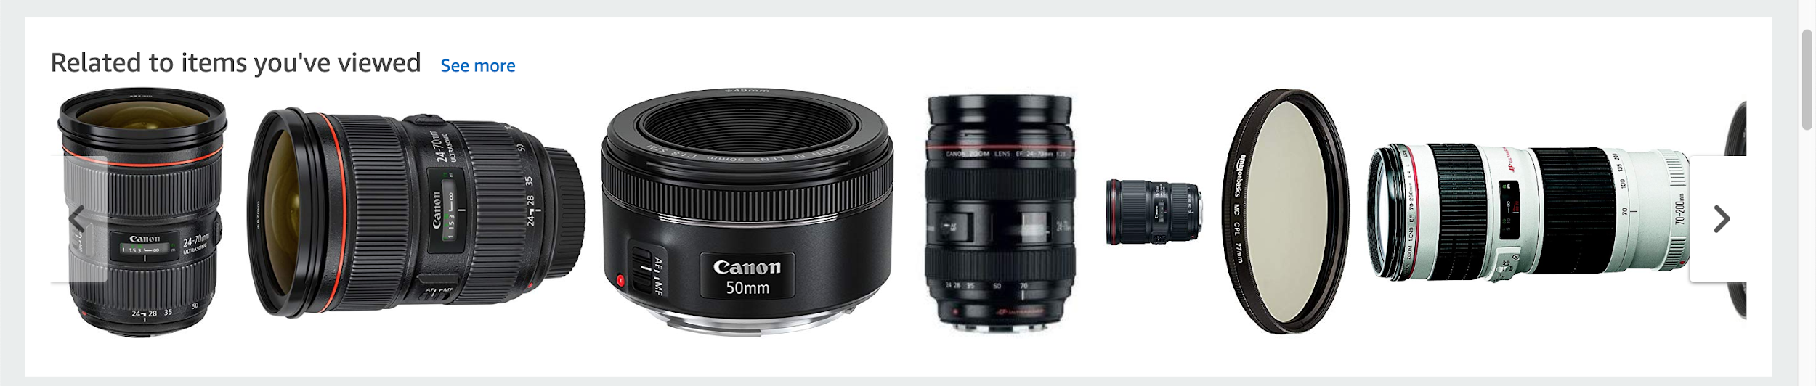
Moreover, Amazon also collect customer purchases and review the data like how many people purchased this product, ratings(1-5 stars,good or bad) to give customers their opinion of the product. It also records how many days people take to give a review after purchase. It also reflects how people “genuinely” feel about the product because it “shows how a specific group of customers rated this product. Customers are assigned based on several factors, including but not limited to past purchases, shipping addresses, and Amazon program memberships. Amazon only displays aggregate ratings and never reveals which customers are in a specific group.” (Amazon). Below is a photo of the “review system” :
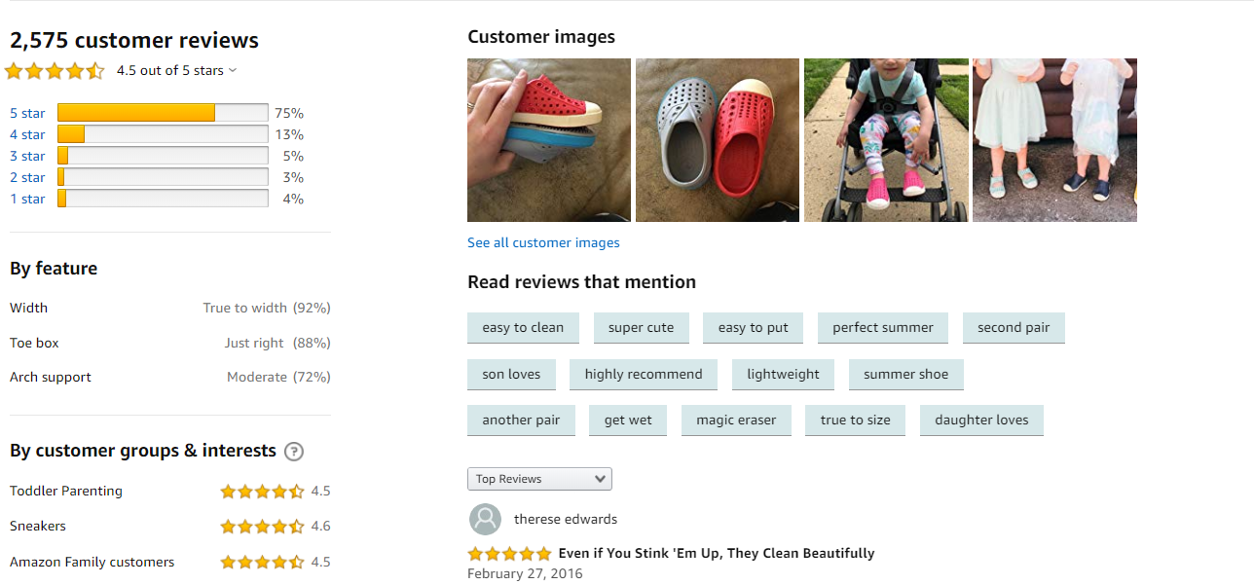

What does this data represent well.

The Amazon preference algorithm is based on the things that are related to the items one has viewed before. It shows things that one might find interesting. For instance, Amazon will automatically record all the objects one have put on the watch list. On the main page, they will display recommended similar products that other people viewed. This is a benefit to both the customer and Amazon. For a customer, they can easily find what they might be interested in and for Amazon, they can use this to increase their sales volume. Products are displayed by means of display, search and classification. Finally, Amazon will also notify the individual if the object that they viewed before have a discount in the future. Then, it will also recommend similar items that other customers liked, according to what they viewed.

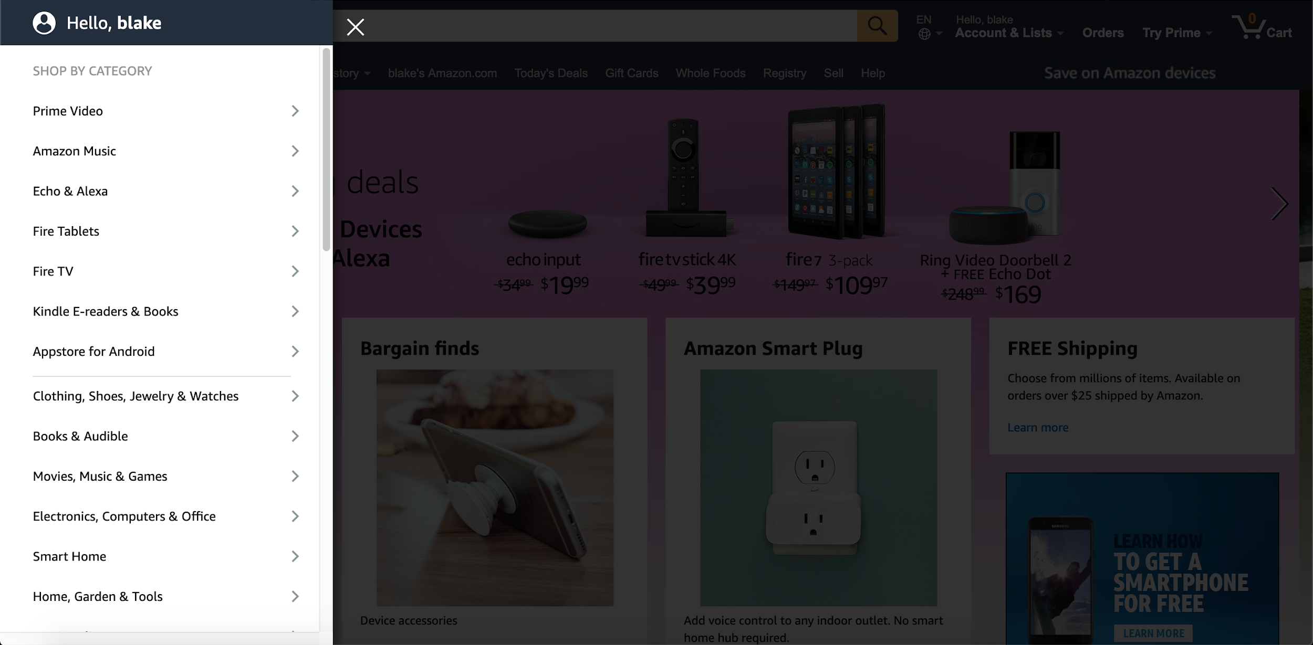

Unlike other websites, Amazon pays more attention to the recommendations made by customers, rather than constantly advertise outside the website. Not only that, but Amazon also pays great attention to the details of the product, the display of the picture, and the specific size, instead of focusing on customer service and consulting. The reason for that is Amazon's main focus are sales, and sales only irregardless of which company or brand the product comes from. In addition, Amazon pays particular attention to customer feedback and evaluation of the product. They are more inclined to listen to the public's ideas, rather than provide arbitrary products recommendations. Amazon does regulate some important policies. The most advantageous aspect of this rule is that through these standardized policies, as a seller, it does not take a lot of time and effort to manage all aspects of selling products. 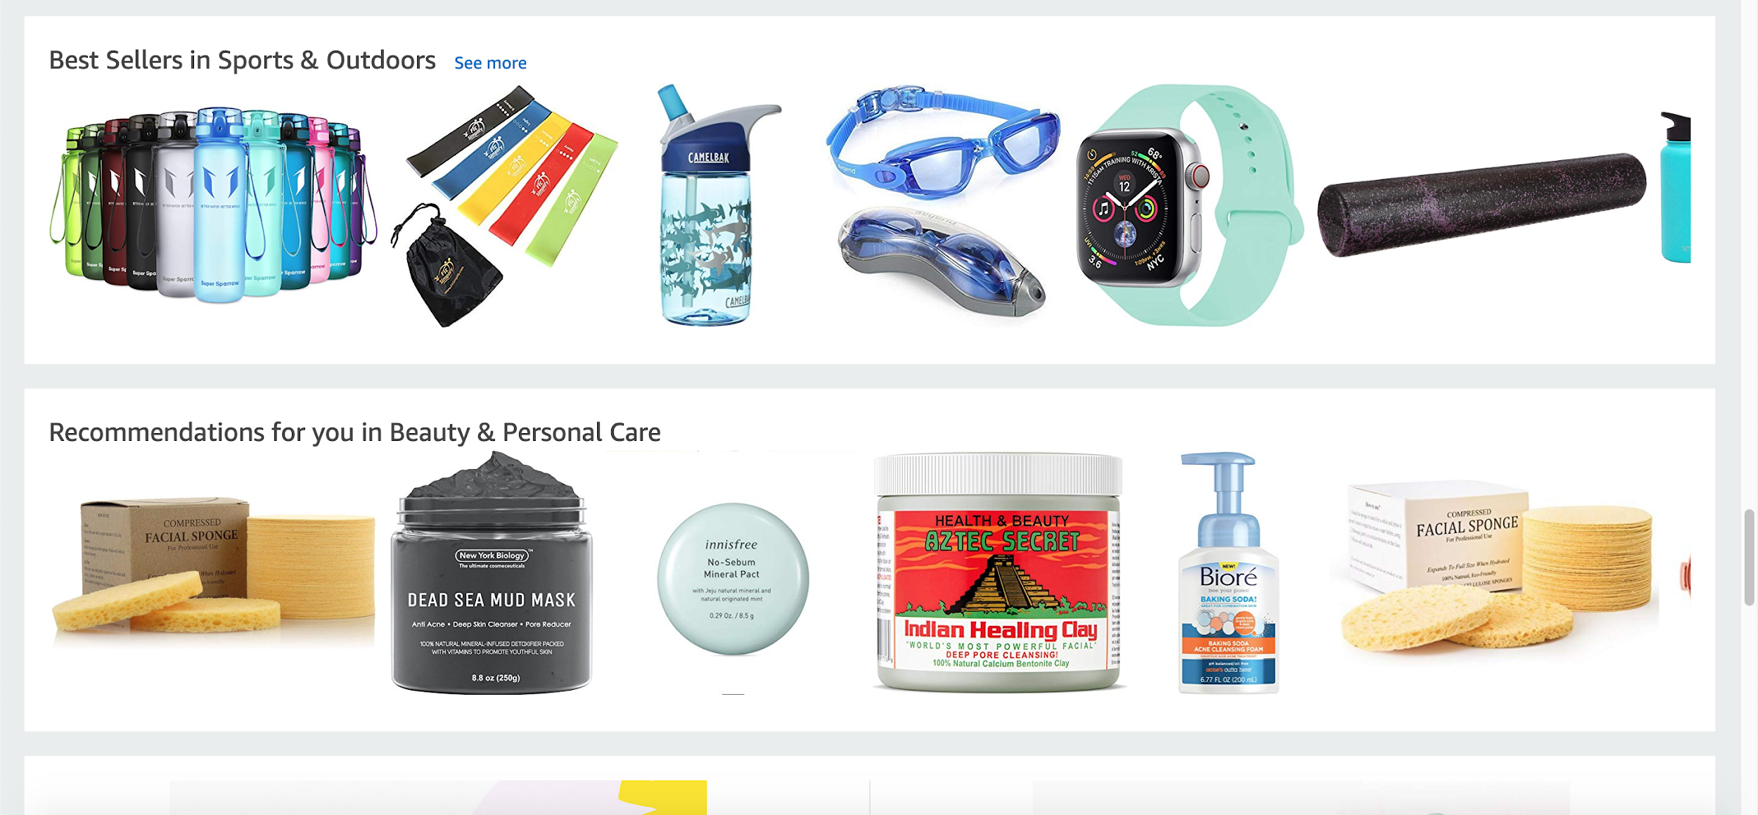

What the data fails to represent.

The data does not take into account personal factors when it comes to both products and its reviews. In the case of reviews, it does not consider the issue of review bombing, unsubstantiated reviews, or worse case, “sponsored” reviews composed by the company in order to boost product favorability. One case could be an individual who has a personal issue with a company may intentionally put a one-star rating and a petty response--that is necessarily reflective of a product’s effectiveness or usefulness. Conversely, someone could provide a five star review yet write a very unsubstantiated review that does not accurately nor effectively describe the feasibility of the product. In essence, the algorithm should find a way to filter the unsubstantiated/review bombs by sorting reviews by a “minimum word count” so potential customers can see the most substantiated and accurate reviews. Lastly, companies may post “Fake” reviews that makes their product seem more favorable than it actually is--which artificially inflates reviews, misleading customers. The data ought to sort and filter genuine, substantial reviews as the ones being shown .
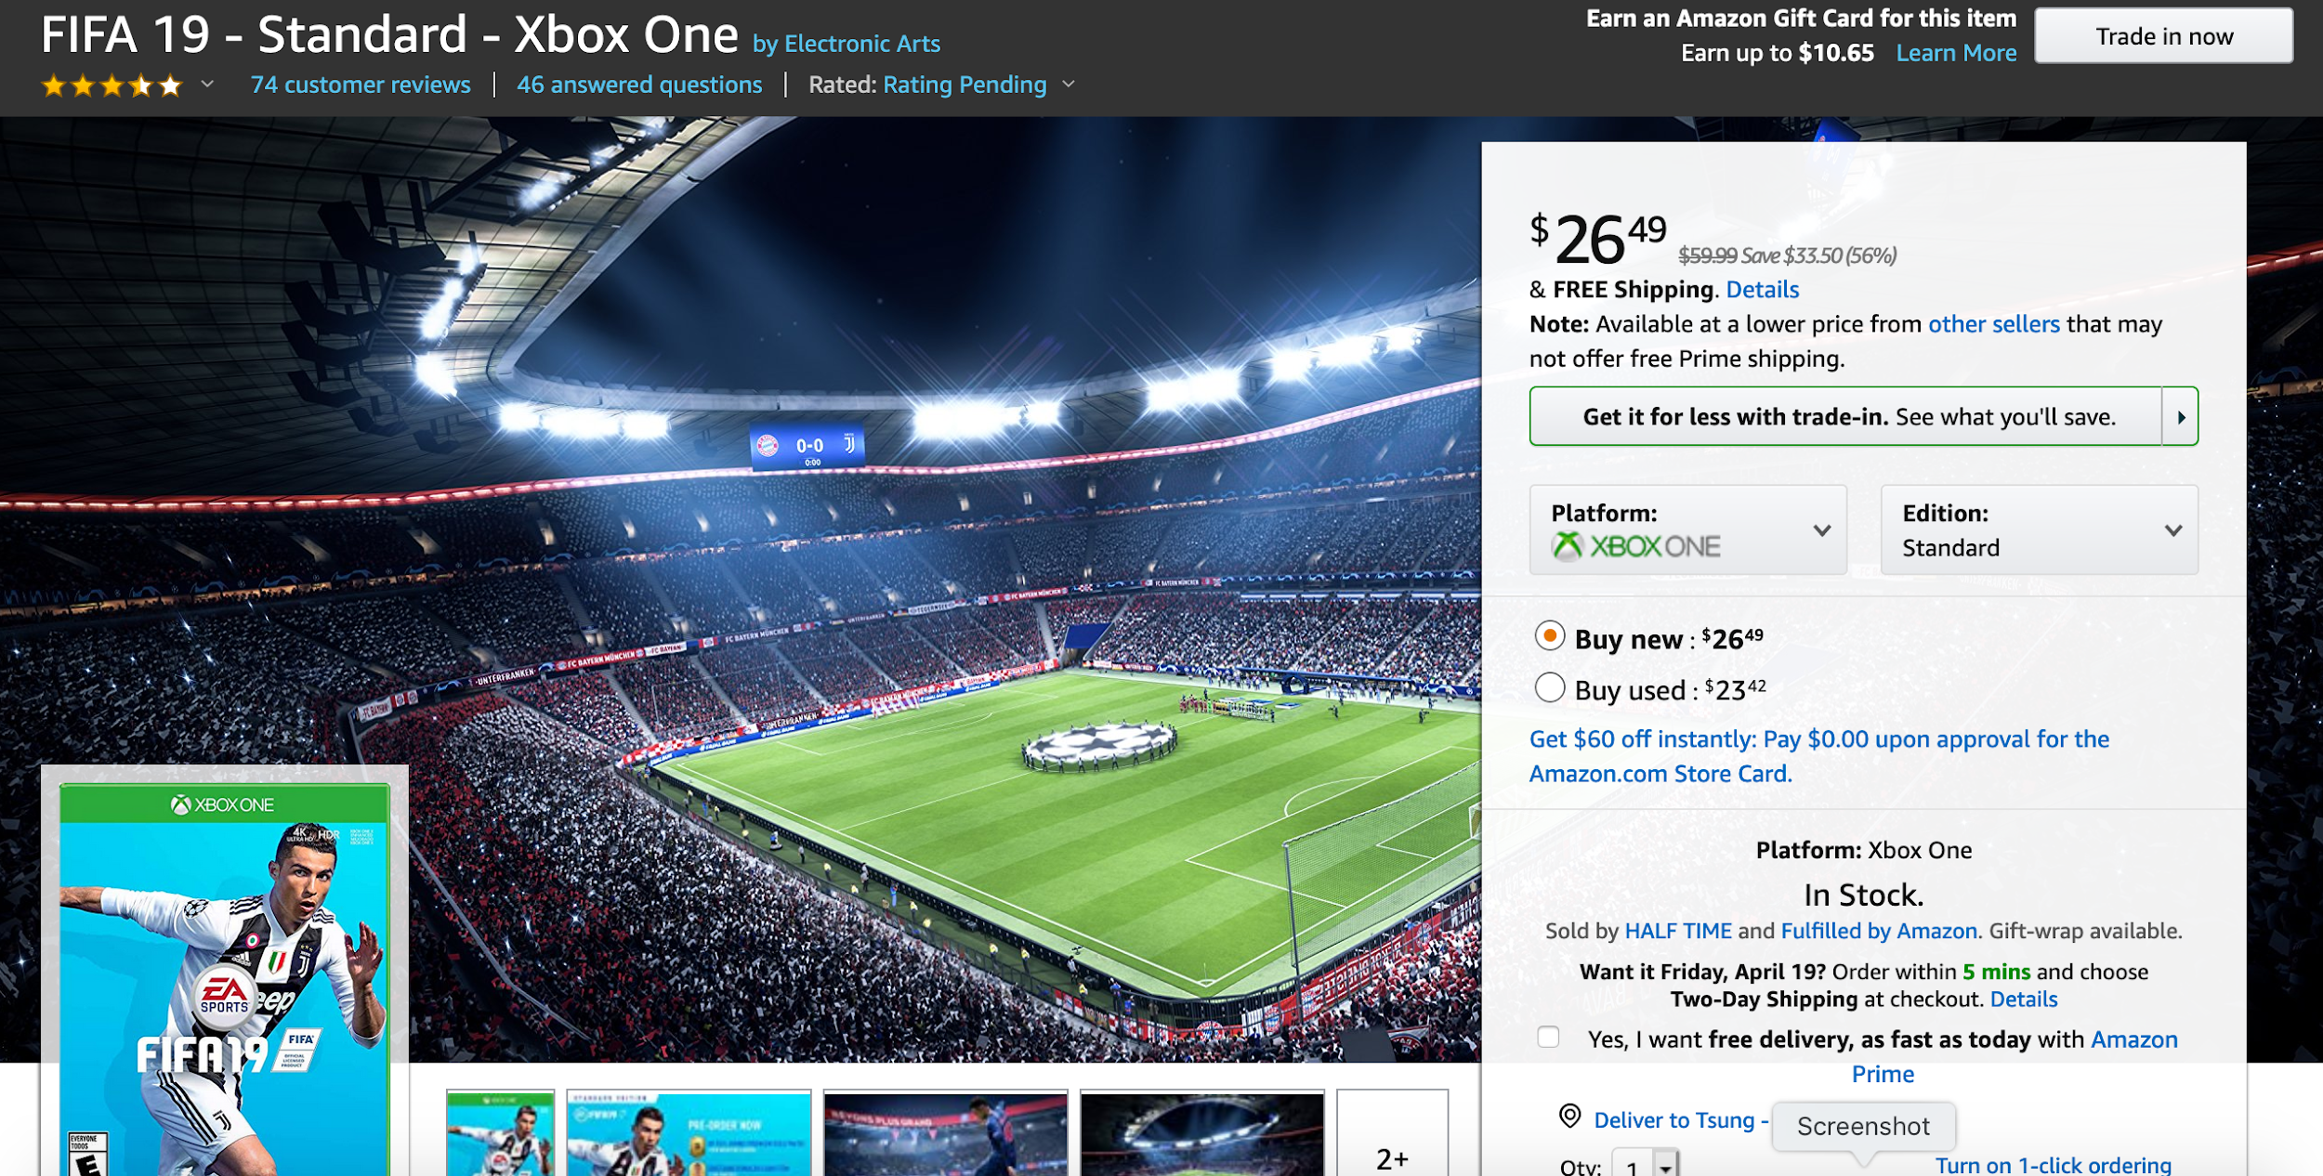
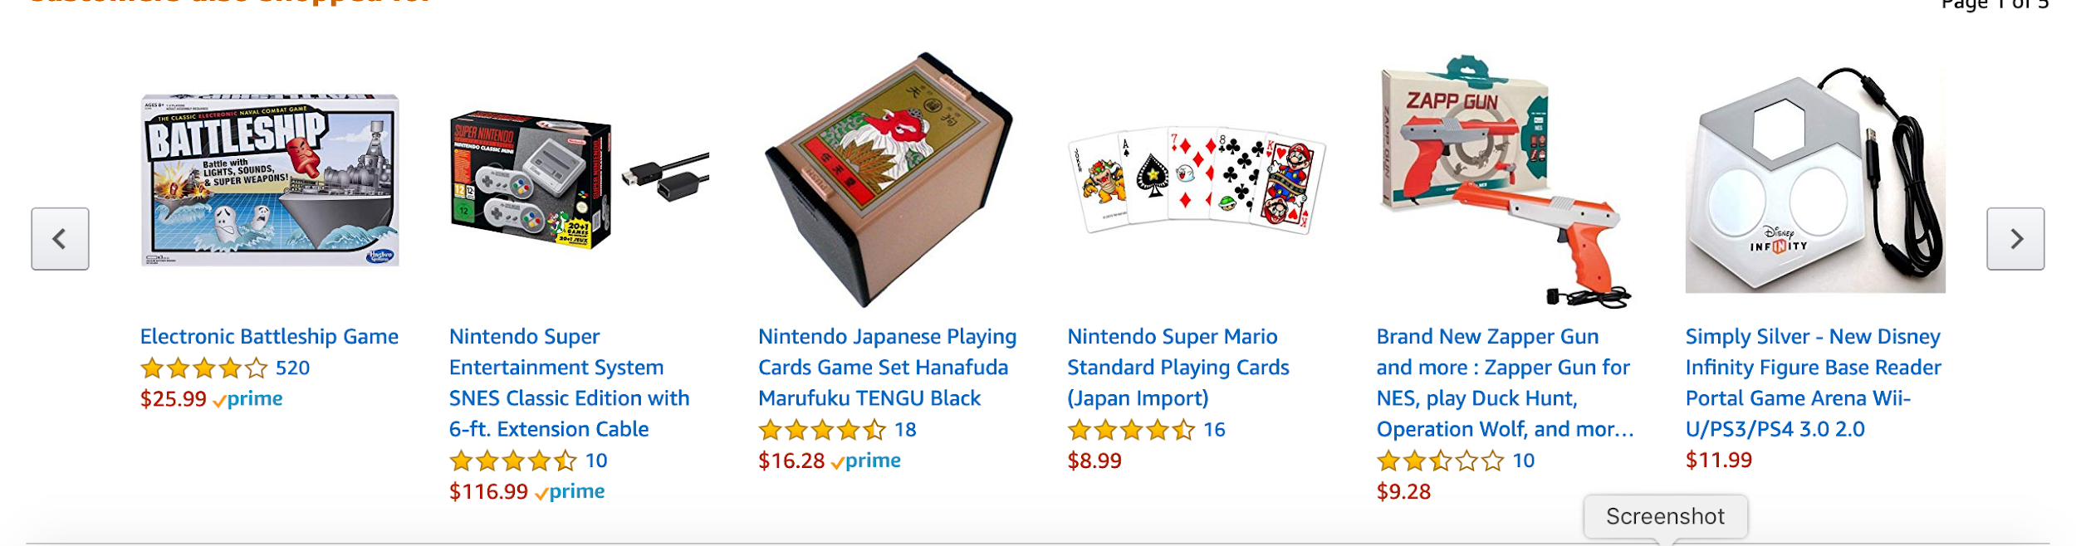
As one can see above, there are some odd recommendations for related products and recommendations. FIFA 19 is a sports game for the Xbox One, yet in the “Customers also shopped for section” the algorithm provides anything but Xbox One games, such as a board game, and playing cards which are completely unrelated to FIFA and does not accurately reflect what the customer would like if they bought FIFA. In other words, the data is being broad, as it does not take into consideration the preference of the customer. The customer who bought FIFA could strictly be an Xbox One gamer or plays on similar platforms, while other customers are not. With that being said, the data just puts Xbox One games and board games, as one general category of “games”. Sometimes, the data will show the same game, but different versions (also region) which shows its inconsistency in being reliable and truly aware of the user preferences.

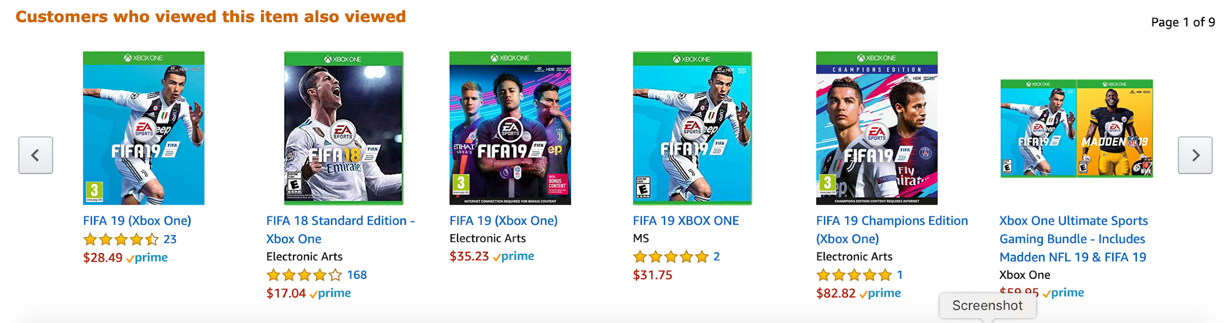

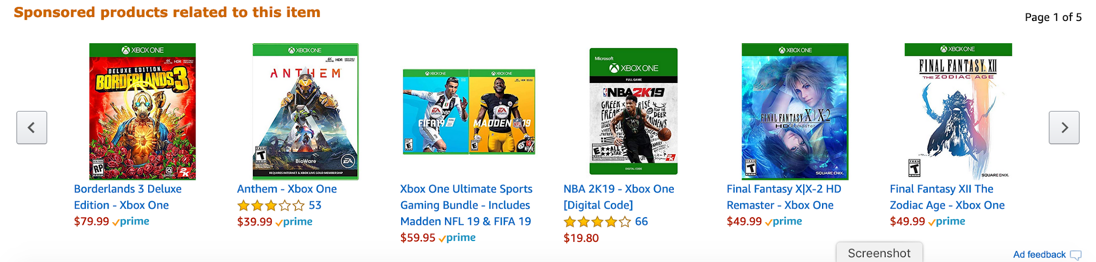

Additionally, the “sponsored product related to this item” section is a bit faulty as well. The commonality is that what is shown are all games on the Xbox One, however they’re not related to FIFA. There is a possibility that one may enjoy FIFA, NBA 2k, and Madden--if they’re sports fans, but what if they are not? The data assumes that a FIFA fan is a fan of all other sports games. Also, action games are not related to sports games, so it supports the fact that the data assumes that just because the customer so happens to like or have viewed a “Xbox One game”. On a less relevant note, this shameless promotion for the publishers of these games and therefore do not necessarily reflect the customers interests in games.

